## PROGRAM DEFINITION

|  |
| --- |
|  |
| * Program untuk cetak laporan deposit |

## RELATED TABLES

|  |  |
| --- | --- |
|  | **Access** |
|  | * RW |

## ROLES

|  |  |
| --- | --- |
|  | **Test** |
| * User yg mempunyai akses ke program |  |

## INITIAL PROCESS

|  |  |
| --- | --- |
|  | **Test** |
| * Set VAR_COMPANY_ID = Login User’s Company ID * Set VAR_USER_ID = Login User ID * Set VAR_LANGUAGE_ID = Login User’s Language ID * Get Property List to Combobox Property [PROPERTY_LIST]:   EXEC RSP_GS_GET_PROPERTY_LIST ‘VAR_CCOMPANY_ID’, ‘VAR_LANGUAGE_ID’  Set Value : CPROPERTY_ID Set Display : CPROPERTY_NAME  As Parameter: CPROPERTY_ID   * Jalankan RSP_GS_GET_PERIOD_YEAR_RANGE dengan parameter, simpan hasil ke VAR_GSM_PERIOD   + VAR_COMPANY_ID   + ‘’ (Empty String)   + ‘’ (Empty String) |  |

## MAIN FORM

### USER INTERFACE

#### INITIAL VERSION

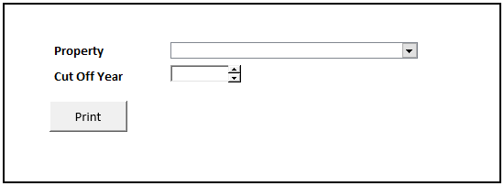

### BUTTON DEFINITION

|  |  |
| --- | --- |
| **Button Name** | **Action** |
| Print | Jalankan PRINT REPORT PROCESS |
|  |  |

### DISPLAY PROCESS

#### FIELD DEFINITION

|  |  |  |  |
| --- | --- | --- | --- |
| **Name** | **Field** | **Type** | **Validation** |
| Property | Set Value : CPROPERTY_ID  Set Display : CPROPERTY_NAME  As Parameter: CPROPERTY_ID | Combobox | * Mandatory * Get DataSource from [PROPERTY_LIST] * IF Combobox Empty   + Display message “Please select property !” |
| Cut Off Year | As Parameter: CCUT_OFF_YEAR | Spinner   * Minimum Value = VAR_GSM_PERIOD.IMIN_YEAR * Minimum Value = VAR_GSM_PERIOD.IMAX_YEAR * Stepping value = 1   Set Default selected value = VAR_CB_SYSTEM_PARAM.CSOFT_PERIOD_YY | * Default Value = Year.Today * Mandatory * IF Date Picker Empty   Display message “Please select cut off year !” |

### PRINT REPORT PROCESS

#### REPORT LAYOUT

PAPER SIZE: A4 PORTRAIT

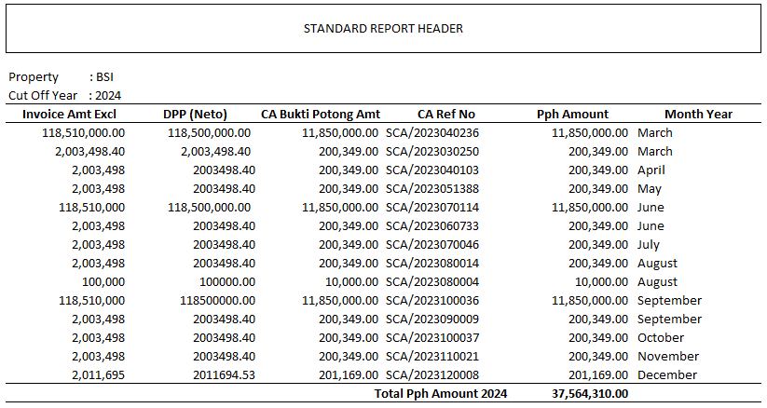

###### REPORT DEFINITION

|  |  |  |  |
| --- | --- | --- | --- |
| **Report** | **Name** | **Field** | **Validation** |
| **HEADER** | Property | Selected Property |  |
| Cut Off Year | Selected Cut Off Year |  |
|  |  |  |
| Detail | Invoice Amt Excl | NINVOICE_AMT |  |
| DPP (Neto) | NDPP |  |
| CA Bukti Potong Amt | NBUKTI_POTONG_AMT |  |
| CA Ref No | CREF_NO |  |
| Pph Amount | NPPH_AMOUNT |  |
| Month Year | CMONTH_YEAR |  |
|  |  |  |  |
| FOOTER | Total Pph Amount | SUM(NPPH_AMOUNT) |  |
|  |  |  |
|  |  |  |
|  |  |  |
|  |  |  |

###### VALIDATION

|  |  |  |
| --- | --- | --- |
| **Field** | **Condition** | **Validation Message** |
| Property | Empty | Please select property ! |
| Cut Off Year | Empty | Please select cut off year ! |
|  |  |  |
|  |  |  |

#### ACTION

|  |
| --- |
|  |
| * Execute this stored procedure:   RSP_PMR03100_GET_REPORT  VAR_COMPANY_ID  , CPROPERTY_ID  , CCUT_OFF_YEAR  , VAR_USER_ID |

# CR LIST

|  |  |  |
| --- | --- | --- |
| **CR** | **Description** | **Notes** |
|  |  |  |